**This is quick summary of machine learning concepts that I’ve been studying for the last weeks.**

Linear Regression Algorithm

Linear Regression does a prediction based on one (independent) variable (X) and a dependent (Y) variable.

**Formula: Y = mX + b**

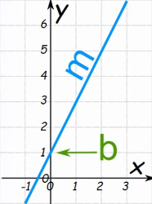

**Ex:**

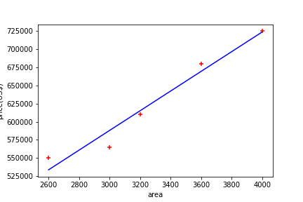

Linear Regression, although, can be used with more than one independent variable:

reg = linear_model.LinearRegression()

reg.fit(h[['area', 'bedrooms', 'age']], h.price)

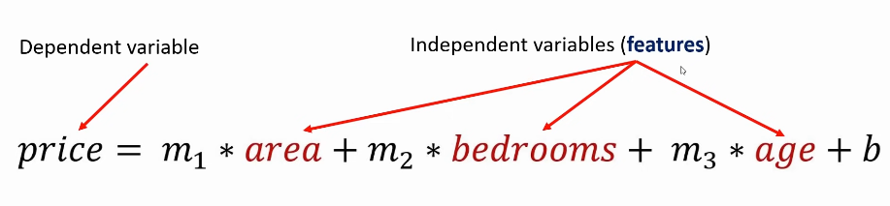

Gradient Descent and Cost Function

“*Gradient descent (GD) is an iterative first-order optimisation algorithm used to find a local minimum/maximum of a given function. This method is commonly used in machine learning (ML) and deep learning(DL) to minimise a cost/loss function (e.g. in a linear regression). Due to its importance and ease of implementation, this algorithm is usually taught at the beginning of almost all machine learning courses.*”

https://towardsdatascience.com/gradient-descent-algorithm-a-deep-dive-cf04e8115f21